Australian Islamic College 2019

ATAR Chemistry Units 3 and 4

Task 15 (Weighting: 5%)

Practical Test

Test Time: 4 Periods
(3 Periods for Practical Work and 1 Period for Validation Test)

First Name | Surname

Teacher

Mark / 49 | Percentage

Equipment allowed: Pens, pencils, erasers, whiteout, rulers and non-programmable calculators permitted by the Schools Curriculum and Standards Authority.

Before you come to class or at the start of class watch this video on YouTube.

Make Soap at Home: A Simple Olive Oil Lye Soap Tutorial. No Frills.
https://www.youtube.com/watch?reload=9&v=o04lrvf1qnE

Section One: Practical Work [8 marks]

You are going to make soap.

Materials per group of 2 students
- 300 mL vegetable oil.
- 84.5 g distilled or deionised water (dH₂O)
- 33.7 g of NaOH
- 1 electric hot plate
- Clean beakers
  - 1 x glass or plastic 1000 mL
  - 2 x glass 500 mL
  - 1 x glass 250 mL
  - 2 x glass 100 mL
- 1 x disposable 1 mL plastic pipette
- 1 x glass stirring rod
- Large kitchen spoon e.g. tablespoon
- 1 x plastic spatula or clean plastic teaspoon
- Electronic or triple beam balances – these may need to be shared
- 2 x long 0-100 ºC thermometers
- Kitchen whisk – three to be shared between all groups
- 3 disposable food containers with lids – Coles 300 mL ‘Cook and Dine Food Containers’
- Paper towels
- 2 x elastic bands
- 500 mL plastic beaker with 150 mL ice in the bottom
- Washup materials – detergent and paper towels.
- Access to fume hood if required
- 1 x permanent marker
- Lab coats, gloves and safety glasses
- Large e.g. 500 mL plastic beaker or other container to use as a waste container.

Safety
During this practical you must wear lab coats, gloves and safety glasses. Ensure that you know the location of the emergency eye wash and how to use it.
Do not put plastic containers such as beakers on hot plates.

Procedure
- Put on a lab coat, safety glasses and gloves.
- Rinse a 200 mL glass beaker with a very small amount of distilled or deionised water (dH₂O).
- Use an electronic balance or triple beam balance to add 84.5 g of dH₂O to the 200 mL glass beaker.
- Weigh out in a separate container e.g. a clean dry 100 mL glass beaker 33.7 g anhydrous NaOH. Slowly add the NaOH to the dH₂O while continuously stirring slowly with a glass stirring rod. Add the NaOH to the dH₂O, not the water to the NaOH, otherwise heat may cause the NaOH to dangerously ‘spit’. Do not stir with the thermometer. Continue to stir until all NaOH is dissolved. Fumes may be produced during this process. Avoid breathing the fumes. Use a fumehood if the fumes become problematic. The NaOH solution is dangerous and will get hot. Place a thermometer in the NaOH solution and monitor the temperature. The NaOH solution should be used when it has cooled to about 43 ºC.
- Weigh into a clean 500 mL glass beaker about 421 g (or about 280 mL) of vegetable oil. Place the beaker on a hot plate and place a thermometer in the oil. Heat the oil until it reaches about 54 ºC. Be careful not to overheat the oil because it will take a long time to cool down.
- When both the oil and the NaOH solution are at about the correct temperature, add the oil to a clean plastic 1000 mL beaker. Add the NaOH solution. Stir the resulting mixture with a plastic spatula or spoon (not an aluminium spatula) for 5 minutes.
- Agitate the mixture with a kitchen whisk on low speed for about 5 minutes, until the mixture noticeably thickens. If the whisk becomes hot or begins to smoke turn it off and let it cool down before continuing.
- Pour the soap mixture into 2 or 3 small plastic food containers and put the lids on. Wrap the food containers in about 5 layers of paper towels and put 1 or 2 elastic bands around to hold the paper towels in place. Put your names on them and leave them for your teacher to check.
- Clean up your work area and return all equipment.
- Show your soap and your cleaned work area to your teacher.
Optional
- Leave your soap wrapped up for 24 hours to set.
- Remove your soap from the moulds and allow it to air-dry for three weeks.

Marks for Section One
- Makes at least one bar of soap [up to 3 marks]
- Evidence of carefully following instructions [up to 3 marks]
- Evidence of remaining conscious of safety at all times
and absence of misbehavior or unsafe behavior [up to 2 marks]

End of Section One
Name ____________________________________________
Section Two: Validation Test [41 marks]

- Triglycerides from animals are generally referred to as ‘fat’ and are solid at room temperature whereas triglycerides from plants are generally called oils and are liquid at room temperature. The difference in melting points of fats and oils can be explained in terms of the structure of the fatty acids that form the triglycerides.

  - Read through all these instructions before answering this question.
You are to draw the following two molecules. The drawings are to illustrate the difference between fatty acids from animal fats and plant oils.

- Draw a fatty acid containing 10 carbon atoms that shows the typical structure of an animal fatty acid.
- Below the first drawing, draw another fatty acid, also containing 10 carbon atoms, that shows the typical structure of a plant fatty acid.
Draw ALL atoms and ALL covalent bonds in both your drawings.
[3 marks]

  - Refer to the molecule of a typical animal fatty acid that you drew in part (a) of this question. List all types of intermolecular forces that may be present between molecules of this substance. List them in order of decreasing strength.
[1 mark; no half marks]

  - Identify by its / their correct name the functional group/s involved in producing the strongest of the intermolecular forces identified in part (b) above.
[1 mark]

  - Draw a diagram to show exactly where the strongest intermolecular force you identified in part (b) of this question is located when it forms between two typical animal fatty acid molecules. You only need to draw the parts of the molecules involved in forming this intermolecular force.
Also label the location of the dipoles on your drawing.
[3 marks]

  - Refer again back to your answer to part (a) of this question.
Compare and contrast (list the differences and similarities between) the type and strength of intermolecular forces present in the two molecules you drew for your answer to part (a) of this question.
Each similarity must be stated within a single, separate sentence.
Each difference must be stated within a single, separate sentence.
[4 marks]

- Without using any ingredients other than plant triglycerides, sodium hydroxide and water, describe one way that you could make a soap with a higher melting point than you did today.
Explain why the change you suggested would work to increase the soap’s melting point.
[2 marks]

- After making soap at home, especially if it is your first time doing so, it is a good idea to check the pH of your soap before using it.
  - If the soap is made correctly, should the pH of the soap be slightly below 7, slightly above 7, or 7?
[1 mark]

  - Why is soap that has been made properly normally the pH you identified in part (a) of this question?
[1 mark]

  - Suppose you checked your soap and found it had a pH of 11.
    - Should you use this soap? Why?
[1 mark]

    - What was most likely wrong with the soap ‘recipe’ if this happened?
[1 mark]

- Using ethanoic acid and propanoic acid as examples, explain why not all carboxylic acids are fatty acids. Include a definition of fatty acids in your answer.
[3 marks]

- Sally is a believer in living an alternative, healthy lifestyle. As such she only eats food bought from the organic food store.
Sally also believes that only ‘pure’ substances should be allowed to touch her skin.
She was recently horrified when a chemist friend told her that soap is not a pure substance, but a mixture, because the vegetable oils used to make her soap are actually a mixture of different triglycerides.
Determined to only use ‘pure’ soap, Sally pays a large amount of money to have her soap made from pure tristearin, a triglyceride containing three identical fatty acids.
In the Chemistry sense of the word, is Sally’s expensive soap a ‘pure’ substance now? Explain why or why not. Do not consider any water present in the soap and assume that during the soap-making process reactants were added in their stoichiometric ratios.
[2 marks]

- Draw the triglyceride that you would use to form soap molecules with the structure CH₃(CH₂)₇CH=CH(CH₂)COO⁻ Na⁺.
You may used condensed structural formulae in your answer.
[2 marks]

- The following diagram shows a structure that is formed during the cleaning action of soap.
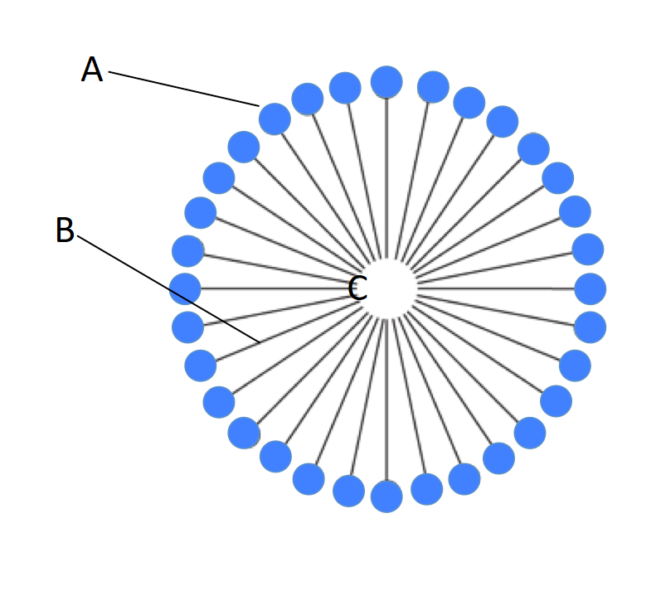

  - Name the structure shown above (the entire structure).
[1 mark]

  - Identify the part of the soap molecule labelled ‘A’ as being hydrophobic or hydrophilic and explain what is meant by this.
[1 mark]

  - During the normal cleaning action of soap structure A is attracted by hydrogen bonding to what important solvent?
[1 mark]

  - Identify the part of the soap molecule labelled B as being polar or non-polar.
[1 mark]

  - Name the two atoms that would predominate in the part of the soap molecule labelled B.
[1 mark]

  - Identify the predominant intermolecular force operating between the soap molecule and ‘grease’ or ‘dirt’ at location C.
[1 mark]

- Explain in words AND with a suitable balanced, ionic equation with state symbols why soaps do not work in water containing calcium ions.
[2 marks]

- Biodiesel can be produced by a trans-esterification reaction between vegetable oil and an alcohol in the presence of sodium hydroxide catalyst. A typical trans-esterification reaction is shown below. The products are glycerol and three methyl esters.

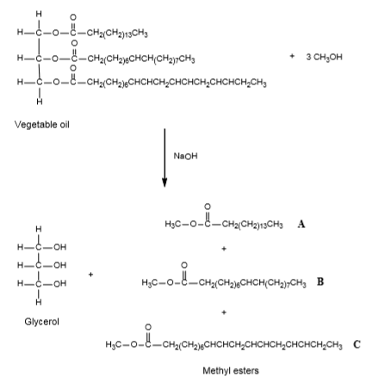

  - Explain the purpose and mechanism of action of the NaOH catalyst in the above reaction.
[3 marks]

  - Name and explain the undesirable side reaction that may occur during the production of biodiesel shown above. Show this reaction using molecule A as your example. Also explain how that side reaction is minimised.
[4 marks]

  - Name the functional group in glycerol.
[1 mark]

